

**Software Engineering and Project Management**

**Research Journal**

**Design Proposal**

Bacteria Scanner integrated in Smart Watches

**Submitted To:** **Submitted By:**

Shelly Garg Ujjwal Kumar Gupta (500091584) Nishant Rastogi (500090864)

DevOps (Hons.)

**Problem Statement**

The unavailability of compact and portable scanners just for detecting the bacteria rate made people sick during the pandemic. If people have those portable scanners, they can scan for bacterial or any viral pathogens that can cause any health issues or just to ensure the rate of pathogens can help the citizens get the right clinical help at the right time.

Integrating biosensors in smart watches to detect bacteria and viruses. The COVID-19 pandemic has opened the gates for researchers to explore the implementation of biosensors and nanotechnology. Essentially, this research journal consists of the incorporation of biosensors into smart watches for detecting bacteria that can cause health problems.

**Introduction**

A biosensor is a tool created to identify or measure a biological molecule, such as a specific protein or DNA sequence. Reverse transcription-polymerase chain reaction (RT-PCR), culturing, and isolation tests are used to detect pathogens or can be used for classical detection. These biosensors and nano biosensors are faster, portable, compact and also an alternative solution for the common viral and pathogens detection.

This research journal contains the integration of biosensors into smart watches. In which the dial of the smart watch will be detachable and the user can use that watch dial to scan the portion of the skin to measure the bacterial presence.

Coughing, sneezing, and a running nose are the most common symptoms of a cold in humans. As humans, we occasionally forget to sanitise our hands, allowing bacteria to be more effective on our skin and blood. While meeting friends with the gesture of a handshake, we share our bacteria with other ones also, and this chain goes on.

Various types of sensors in smart watches used for the measuring the activeness along with basic health parameters. A smart watch or fitness band typically has 6-7 health-related sensors.

Optical heart rate sensor:

The optical heart rate sensor measures the number of heartbeats per minute. An optical cardiac sensor is included with almost all fitness trackers and smart watches. by using the light to measure the wrist's blood flow rate. Less light is reflected back to the sensor and is detected as a heartbeat when the heart beats because blood travels swiftly inside the artery during a heartbeat.

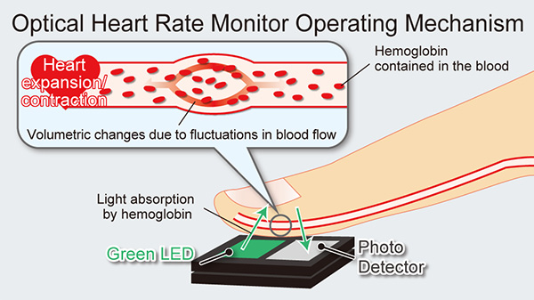(img credit: [www.rohm.com](http://www.rohm.com))

SO2 monitor:

Utilized to measure blood oxygen levels is the SpO2 monitor. The monitoring and reporting at the colour of the blood to determine the amount of oxygen present. Deoxygenated blood has a somewhat darker red hue than fully oxygenated blood in our arteries, and it returns to our lungs through our veins. Through our wrist, the sensor gauges the proportional reflection of red and infrared light from your blood, seeing how it changes when our heart beats.

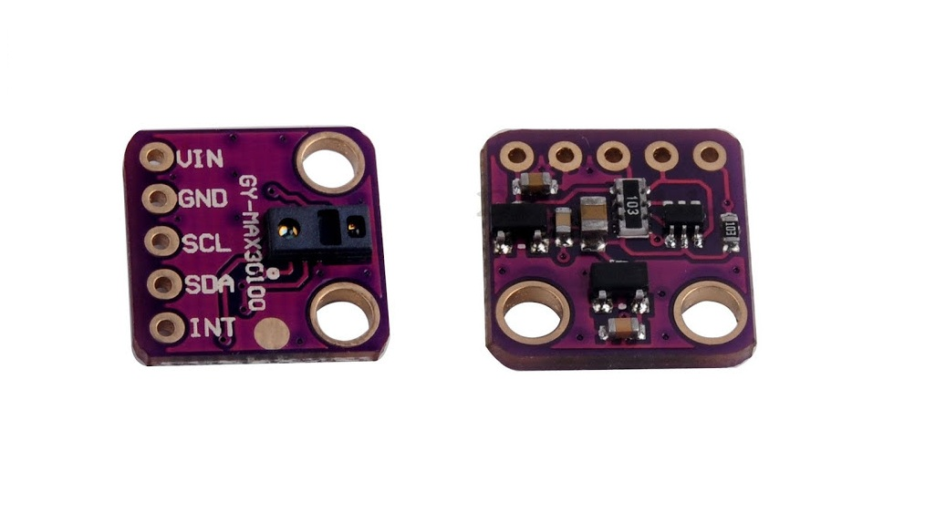

(img credit: leetsacademy.blogspot.com)

ECG sensors:

The brief electrical impulse that our heart puts out with each heartbeat is picked up by an ECG sensor. Through the electrodes on the smart watches or fitness bands, this sensor picks up this faint heart signal.

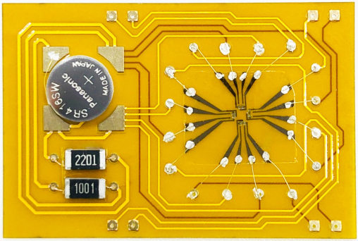(img credit: [www.hku.hk](http://www.hku.hk))

Skin Temperature sensor:

Skin temperature sensors pick up on minute temperature changes to determine whether you're about to get sick, such as a fever, or whether menstruation is beginning.

**Literature**

Incorporating biosensors into smart watches while maintaining the functionality of the other specified sensors. Making a wristwatch wrist band that can support the dial's removable mechanism while maintaining a stylish appearance. making the dial extremely durable so that it can withstand drop testing. Despite being removable, the dial should be composed of a sturdy material, or silicon and plastic can be blended. or any other fibre, provided that it does not interfere with the sensors when measuring, can be utilized for the dial.

**Bio-Technical Aspects-**

Photoplethysmography is the term for the use of light to measure heart rate. The instrument detects the change in red blood cell concentration as the blood vessels dilate and constrict; that is, as the blood vessels dilate, they absorb more green light, whereas as they constrict, they absorb less green light. A software algorithm converts changes in light intensity measured by the detector from the reflected light into your pulse rate.

Advances in battery technology have opened the door for more sensors with a higher degree of accuracy in wearables. The mysterious element of the COVID-19 pandemic was that the illness results in **"silent hypoxia,"** a condition where oxygen levels in the body become abnormally low without patients displaying symptoms of respiratory distress. The most accurate way to assess SpO2 is through examining a blood sample, however pulse oximetry is the approach that medical professionals most frequently employ. Similar to optical heart rate monitoring, it entails applying an optical device to a finger or ear lobe. This device drives light through the skin and towards a detector.

**Smartwatch History**

The earliest wearable technology took the form of a chest strap that sent nearby data receivers’ real-time electrocardiogram (ECG) indications of a person's heart rate. The first programme for analyzing heart rates to find changes and anomalies over time followed this in the early 1980s.

In the latter half of the 1980s, the first watches with optical sensors for heart rate monitoring debuted. The 1990s saw the introduction of more sophisticated timepieces that could gauge blood pressure using electrical signals.

As an AI-enabled medical device, the smartwatch. An ordinary watch with a built-in computer is a smartwatch. The newest smartwatches feature touch-screen interfaces with a variety of daily-use apps, including a medical app.

The region that the sensor and scanner in the watch's dial scan can be directed to the monitoring section, where an algorithm can be used to calculate the rate of bacterial growth on the user's skin.

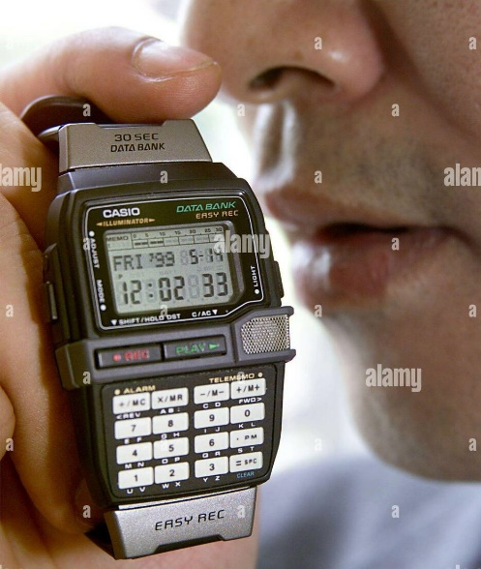

(img credit: [www.alamy.com](http://www.alamy.com))

This Easy Rec watch was released by Casio in 1999.

The capacity to record 30-second audio memos was its main feature.

There are numerous approaches and procedures for detecting bacteria:

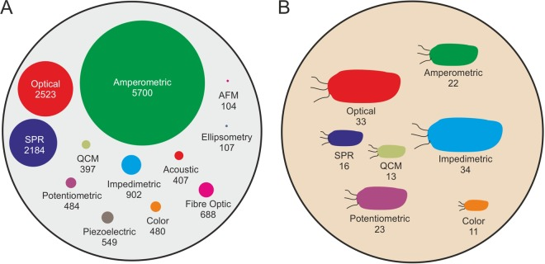

(Img credit: [www.ncbi.nlm.nih.gov](http://www.ncbi.nlm.nih.gov))

**Methodology**

This research paper considers the desiring methodology regardless of the prototype model.

The methods taken to propose a smart watch design that incorporates biosensors are described in this section.

**Review**

The review was conducted with four distinct goals in mind, which were based on the research questions:

* to examine wrist-worn electronics' sensors. Environmental sensing was demonstrated by the literature review.
* to examine techniques for analysing data from wrist-worn devices intelligently.
* to examine techniques for visualising parameters obtained from wrist-worn sensors.

The research has several limitations (inclusion criteria):

* limited to wrist-wearable devices;
* limited to sensors which are used as an integral part of a prototype or commercial devices

**DESIGN**

Implementing the design phase of the Software Development Lifecycle. Incorporating biosensors into the watch without interfering with the functionality of the other sensors. Biosensors have traditionally varied in size depending on the use case; however, in order to incorporate it into the watch, we must reduce the size of the biosensor using miniaturization techniques or convert it to nanoscale. Given that we wear watches on a daily basis, we must keep them light in weight, which can be accomplished through the aforementioned processes.

The live-size design of the watch that incorporates a biosensor is shown below:

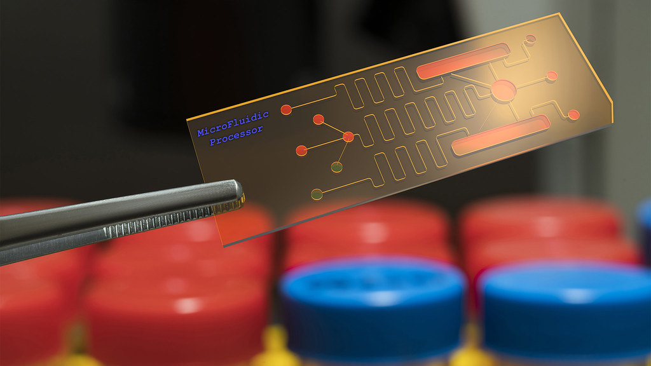

(img credit: [www.bath.uk.ac](http://www.bath.uk.ac))

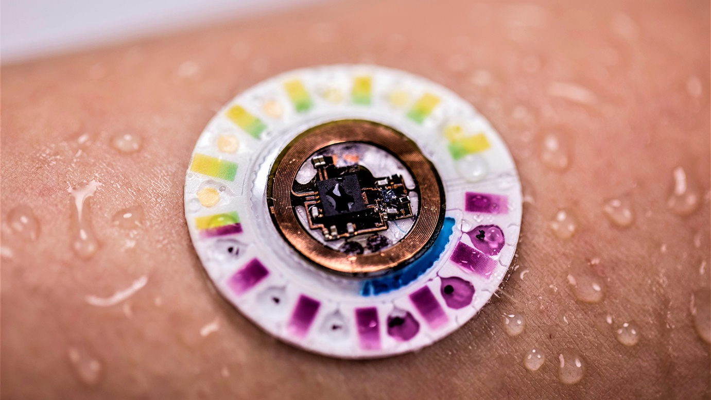

(Img credit: [www.engr.ncsu.edu](http://www.engr.ncsu.edu))

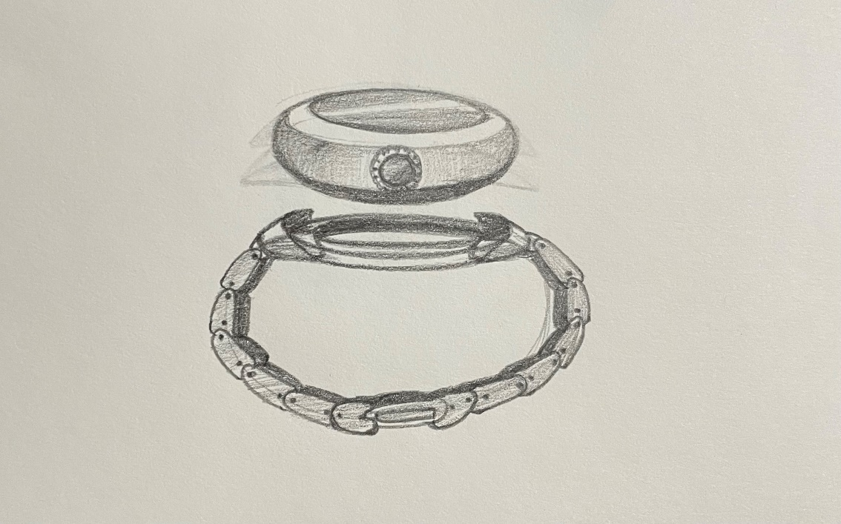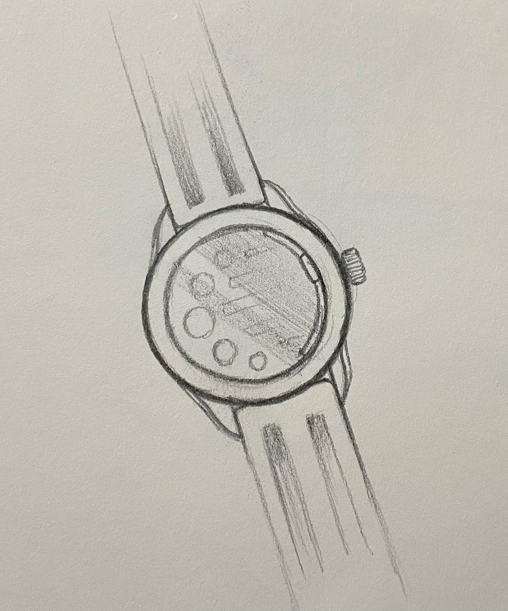

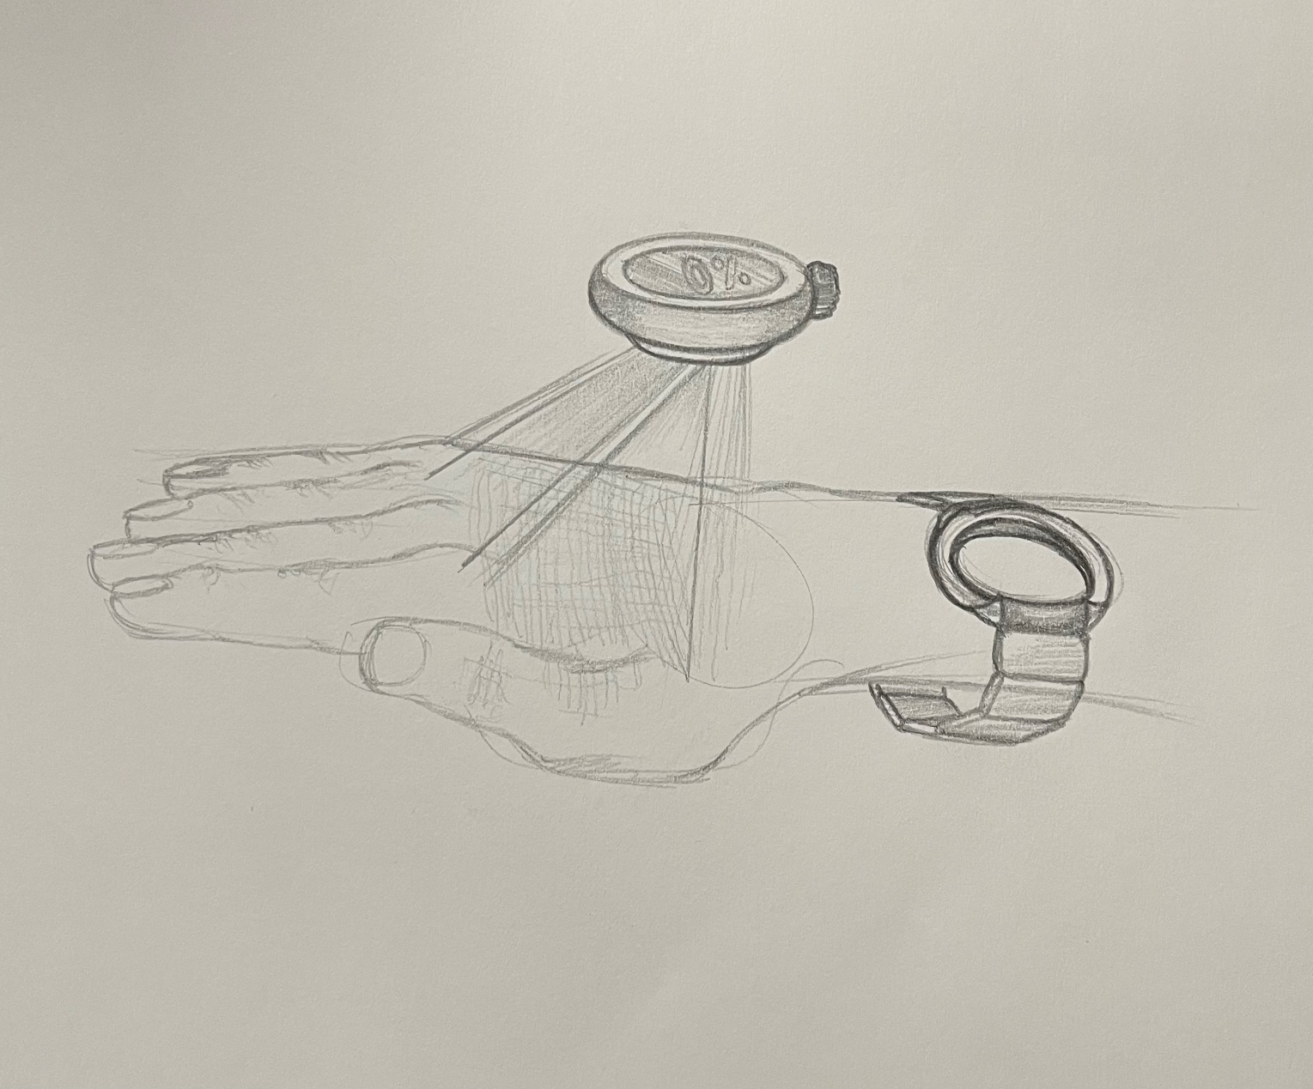

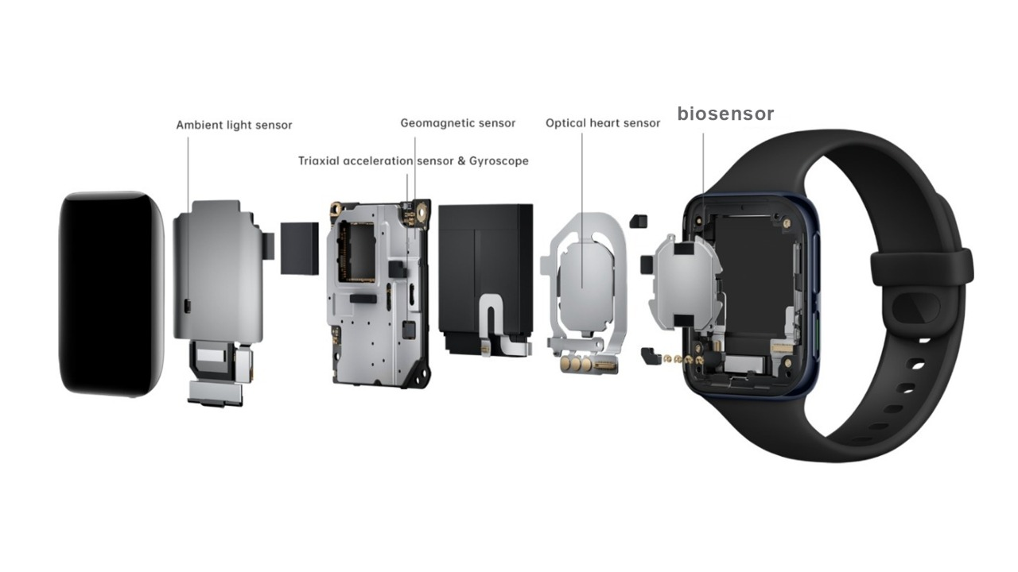**Interior structure of watch with the Biosensor:**

(Img credit: [www.wearablestouse.com](http://www.wearablestouse.com))

**Limitations:**

There are a number of prospective obstacles or constraints relating to the sensors, material that will be utilized in case of the detachable dial, that should be communicated to the designer and general public by implementing the biosensors in smart watches.

The following list of limitations has been identified and needs to be considered:

* **Miniaturization of sensor:**

It is the process of manufacturing anything incredibly small using contemporary technology: A prime example of the advantages of miniaturization is the silicon chip. shrinking in size or producing less.

In the modern era of technology, all sensors have begun to become nanosized or can be referred to as nano sensors. However, the miniaturization of these sensors has its own restrictions or challenges. It can be difficult to reduce the size of a biosensor without sacrificing the sensor's actual functioning.

* **Restricted scanning:**

When using the detachable dial of a smart watch to scan for bacteria or viruses, it is important to remember that the range of the skin the dial is scanning should be specific (e.g., 15cm-20cm). If the range is too wide, the large scanned dataset may produce inaccurate results, and continuing with the same theme, a large scanned dataset will require a large calculation by the algorithm in the watch, which may result in high battery drain.

* **Case material Issue:**

while bearing in mind that the proposed design features a smart watch with a detachable dial. Therefore, it is important to use a durable material for the dial's shell or body so that it can withstand

frequent drops when it is dropped from the user's hand. Making the bracelet or strap case in which the dial will be fitted after scanning the skin's surface should be done using a magnet that should be placed in the watch so that it does not interfere with the operation of the sensors while obtaining readings or during scanning.

**Conclusion**

The unavailability of compact and portable scanners just for detecting the bacteria rate made people sick during the pandemic.

The people can receive the proper clinical assistance at the appropriate time if they have access to portable scanners that can be used to check for bacterial or viral pathogens that may cause any health issues or simply to ensure the rate of pathogens.

The design of successfully integrating biosensors into our smart watches for the scanning of viruses and other pathogens that are present on our skin's surface is presented in this study journal.

**Future Scope**

By incorporating these biosensors into various wearables like tattoos, garments, and bracelets, new advancements can be made. One such invention is self-powered wearable biosensors, but other aspects of health are also discussed, such as physiological indications like bodily mobility, temperature, and vital signs.

**References**

* [www.mdpi.com](http://www.mdpi.com)
* [www.ece.ucf.edu](http://www.ece.ucf.edu)
* [www.ncbi.nlm.nih.gov](http://www.ncbi.nlm.nih.gov)
* wearablestouse.com
* [www.google.com](http://www.google.com)
* link.springer.com
* [www.sciencedirect.com](http://www.sciencedirect.com)
* [www.engr.ncsu.edu](http://www.engr.ncsu.edu)
* [www.bath.uk.ac](http://www.bath.uk.ac)
* [www.ncbi.nlm.nih.gov](http://www.ncbi.nlm.nih.gov)
* [www.alamy.com](http://www.alamy.com)
* [www.rohm.com](http://www.rohm.com)
* leetsacademy.blogspot.com
* [www.hku.hk](http://www.hku.hk)
* [www.wearablestouse.com](http://www.wearablestouse.com)